**Azure Virtual WAN**

Azure Virtual WAN is a networking service that brings many networking, security, and routing functionalities together to provide a single operational interface. These functionalities include branch connectivity (via connectivity automation from Virtual WAN Partner devices such as SD-WAN or VPN CPE), Site-to-site VPN connectivity, remote user VPN (Point-to-site) connectivity, private (ExpressRoute) connectivity, intra-cloud connectivity (transitive connectivity for virtual networks), VPN ExpressRoute inter-connectivity, routing, Azure Firewall, and encryption for private connectivity.

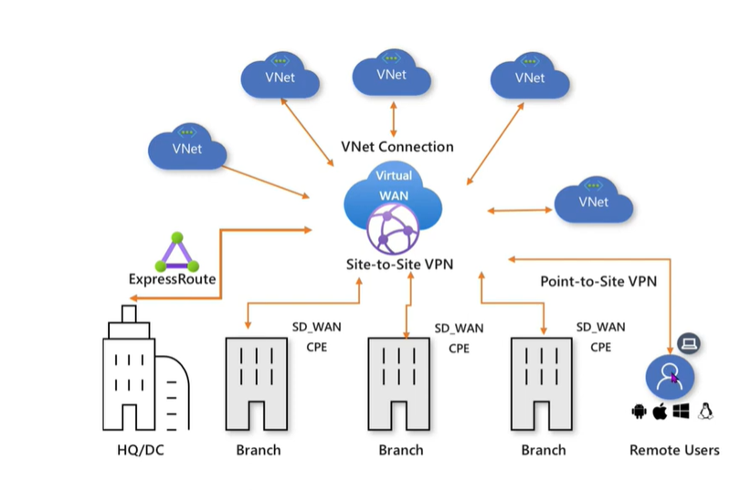

Here we have on premises Head office and different branch and we have different resource deploy in different VNET and want to access it via on premises than we setup wan.

Vnet, different branch are spoke nd we make hub as WAN

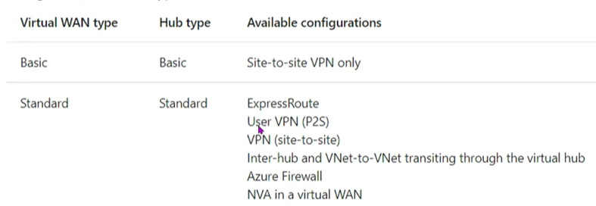

We are able to convert basic plan to standard but not able to convert standard to basic

**Configuration:**

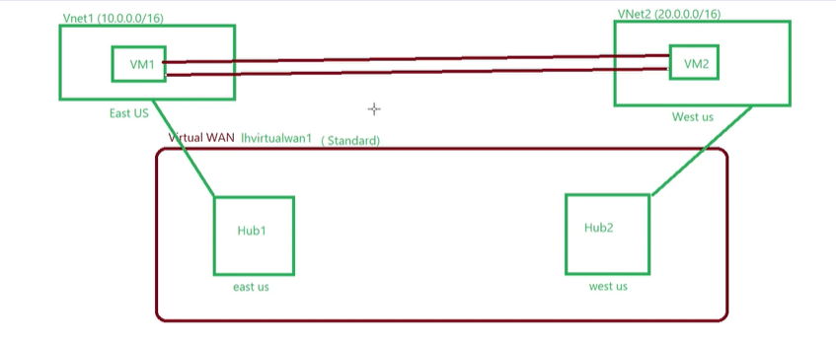

First we create 2 VNET in 2 different region and deploy vm to it

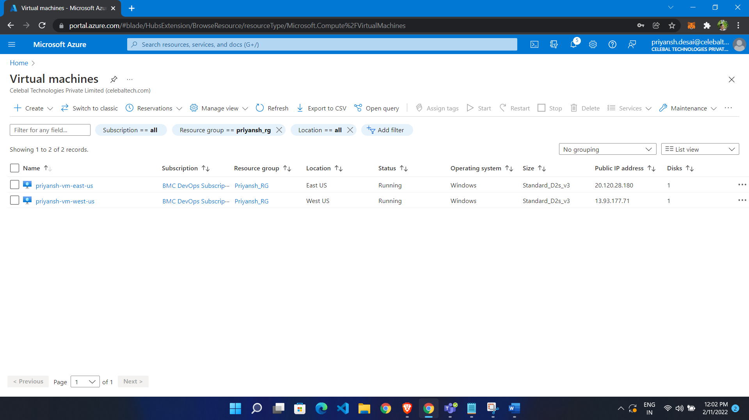

Create WAN

* Search virtual WAN
* Click create
* Choose location
* Click create

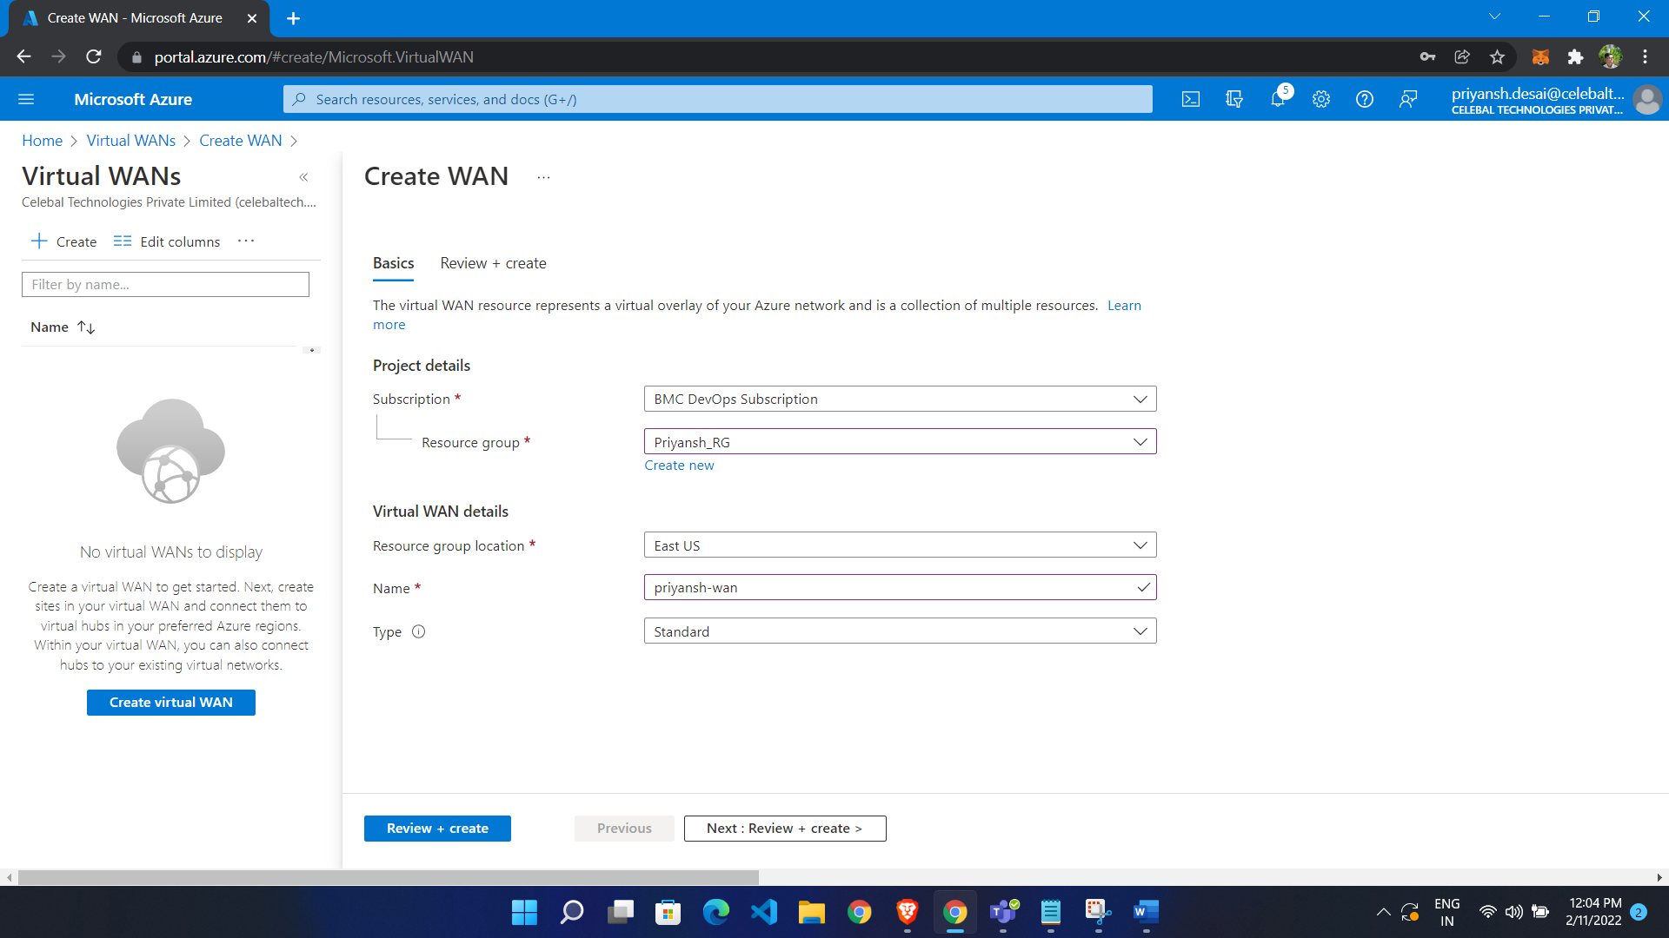

**Create HUB**

* Select HUB from left side menu
* Click new HUB
* Give name
* Give private ip address space
* If we want to connect with p2s , s2s and express route than we have to enable it

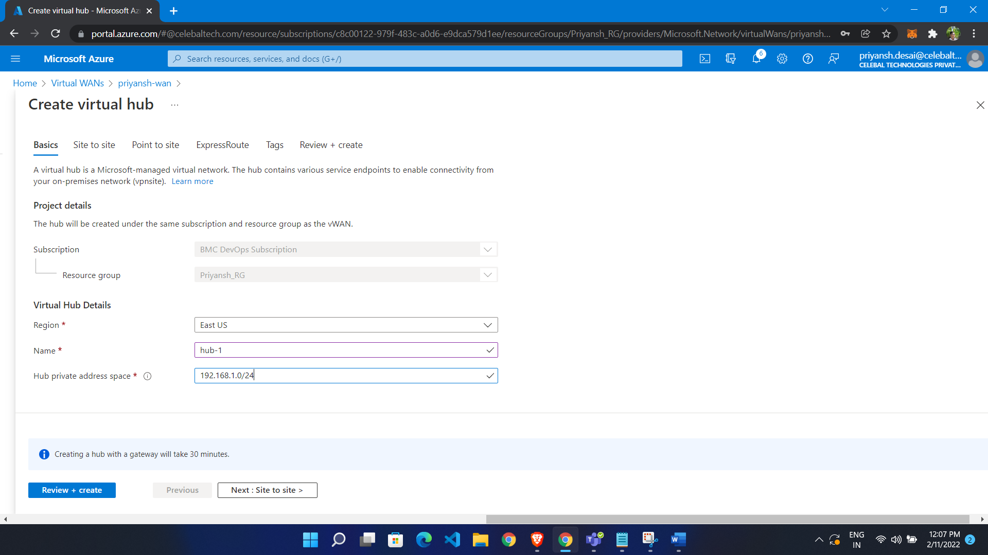

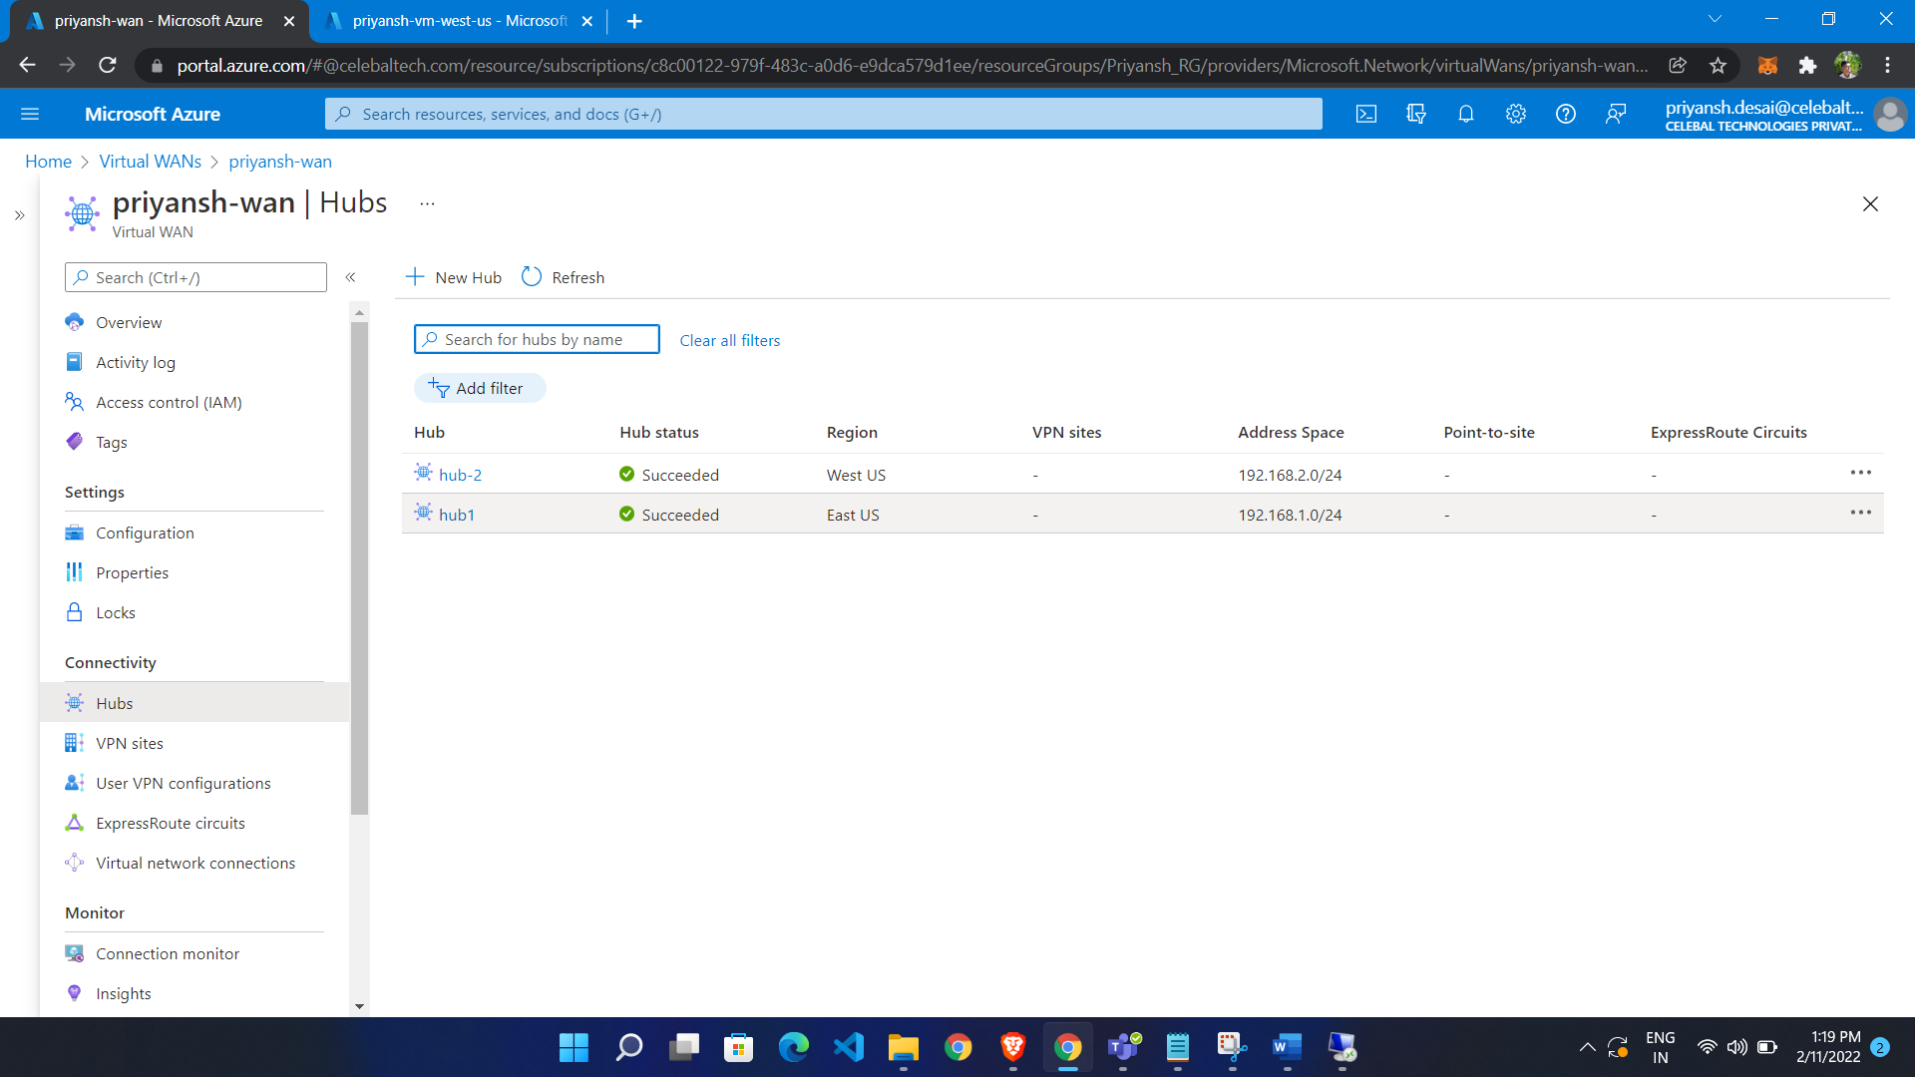

Now Add connection to VNET

* Give name
* Select hub
* Select RG
* Select VNET

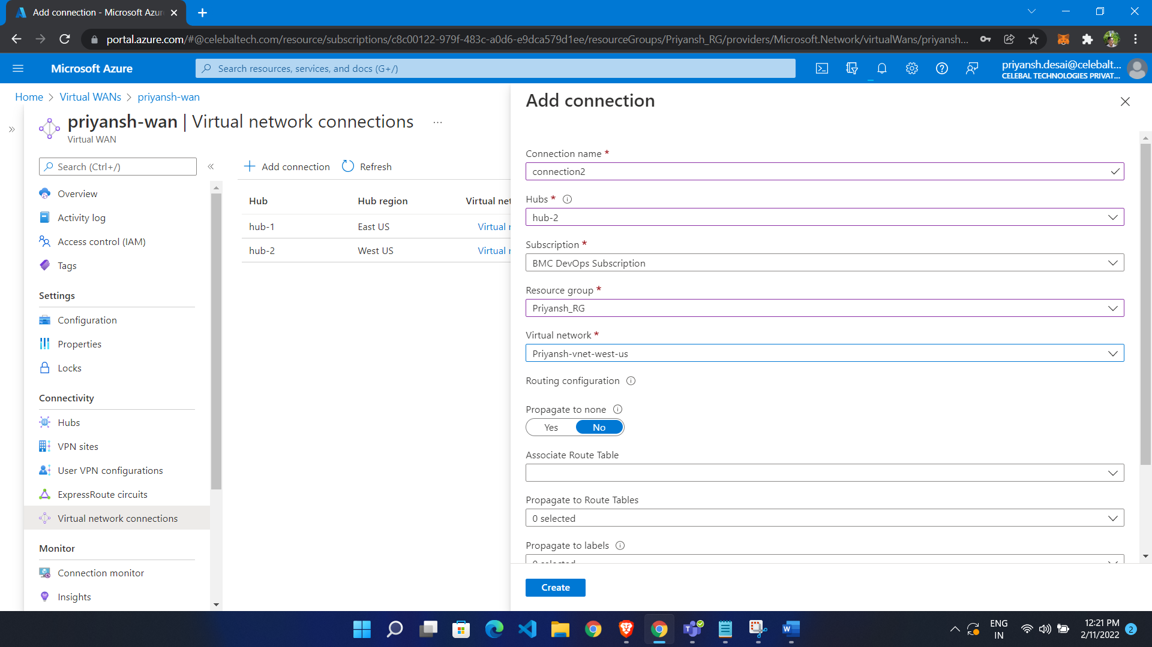

Connection created

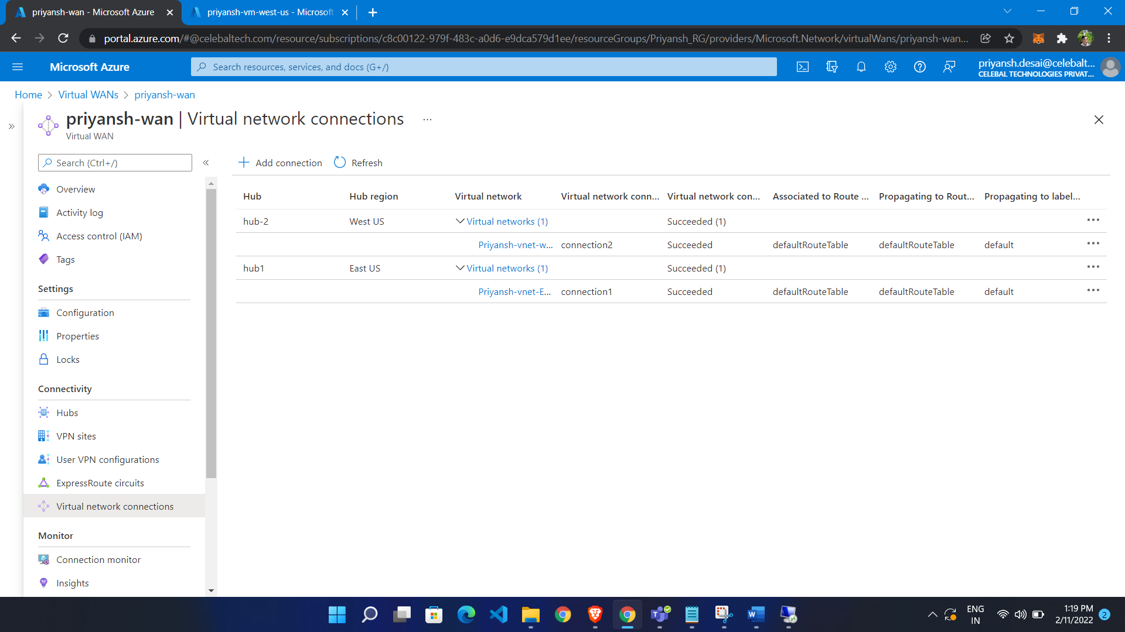

We are able to ping vm in east us to vm in west us

